Christ College Rajkot

Trendsetters Club

Report 2024-25

Event: Management Synergy

Event Dates: 31 January, 1 February 2025

Event Description:

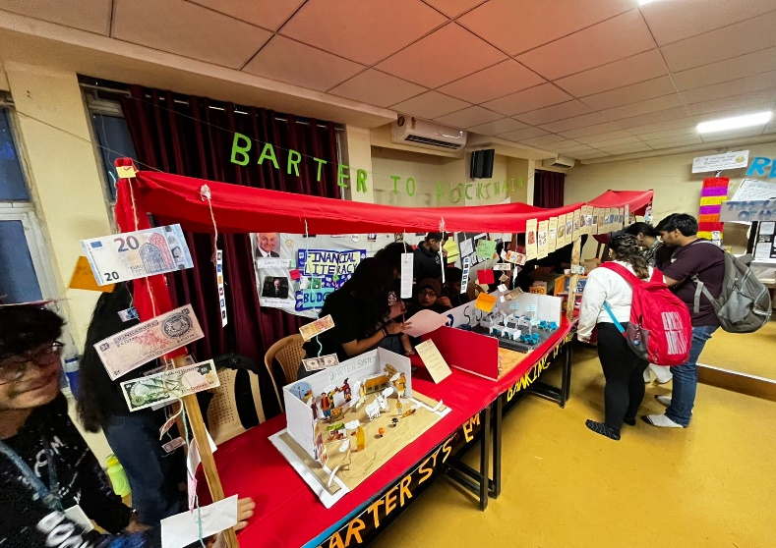The event was held to make participants and viewers (visitors) explore the world of Management. Participants displayed evolution, recent developments and major contributions in the three functional areas of Management – HR, Marketing and Finance. In total 3 teams each comprising 15 students participated in the event. Mr. Yasin Dodhiya (Sr. executive – HR), Mr. Rajit Kothari (Executive Director, Ashutosh Financial Services Pvt. Ltd.) and Mr. Chetan Pathak (Assistant Professor, CIM) were judges for this event.

Event: Connect & Conquer

Event Date: 22 October, 2024

Event Description:

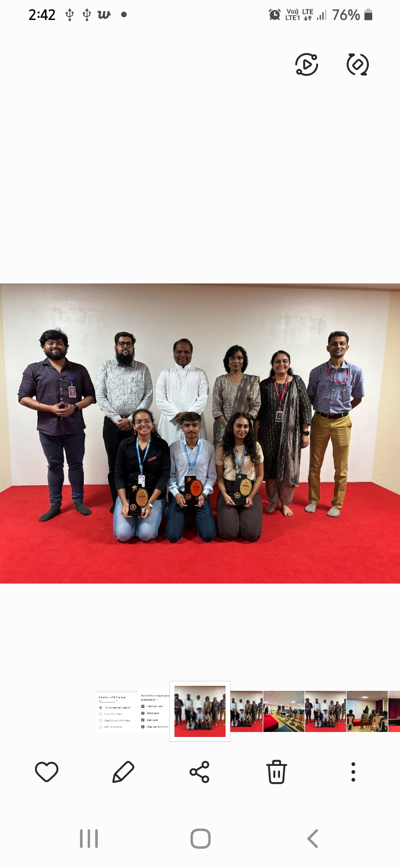The event was conducted on 22 October, 2024 from 12 noon onwards at Students’ Conference Hall (Room no. 112). The objective of the event was to encourage critical thinking and analytical skills among students and to allow participants to challenge their thinking and presentation skills in a supportive setting. 25 students participated in the preliminary round out of which 9 were selected for the final round. Judges of the final round were Mr. Nimit Ganatra and Mr. Moiz Chauhan.

Event: Adversity to Advantage

Event Date: 28 September, 2024

Event Description:

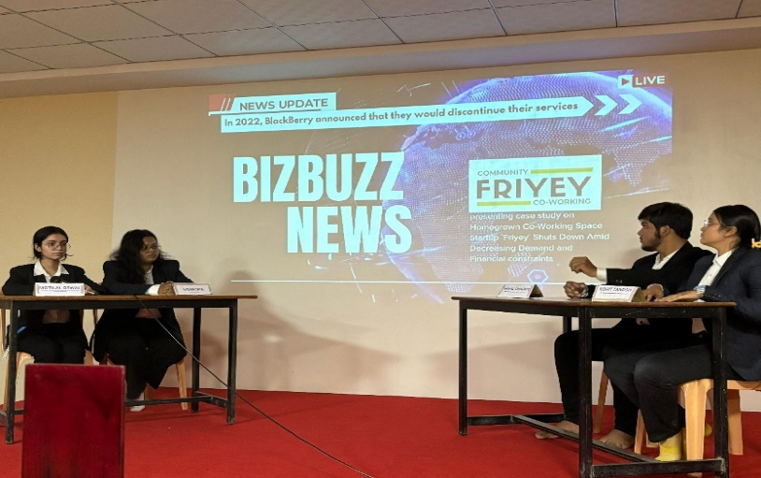The event Adversity to Advantage – a case study competition was held on 28 September, 2024 from 12 noon onwards at Students’ Conference Hall (Room no. 112). The objective was to foster critical thinking by identifying the exact issues leading to business failures and proposing practical and feasible solutions as well as to develop participants’ presentation and communication skills. Judges of the event were Mr. Kamal Vyas and Mr. Hiren Kotadia.

Event: Inaugural Ceremony

Event Date: 17 August 2024

Event Description:

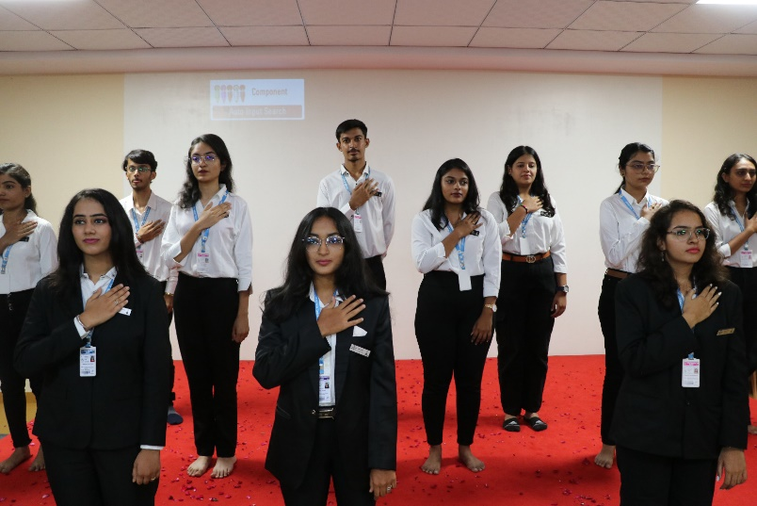The inaugural ceremony of the Trendsetters’ club was held on 17 August, 2024 from 12 noon onwards at Students’ Conference Hall (Room no. 112). The objective of the ceremony was to give an idea about the objectives, structure and activities of the club to the new members. The purpose was also to make office bearers and student coordinators of different committees take oath for their dedicated and sincere contributions in the club.